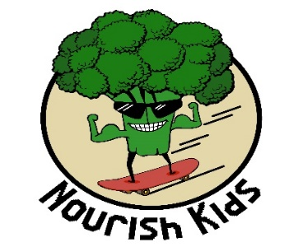
Nutrition Tips
- Eat the whole fruit instead of the juice – you will get the fibre
- Have a protein rich breakfast every day
- Try to make fruits and vegies fill up ‘half your plate’
- Eat a rainbow of different coloured fruit and veggies
- Choose real, whole foods over processed and low-fat
- If you eat fish, eat salmon twice a week – make it wild salmon if possible
- Eat a raw fruit or veggie with every meal to aid with digestion
- Increase your probiotic intake
- If you eat grains, make them whole grains
- Combine good eating habits with exercise and relaxation

‘Nourish Kids’ 5 worst foods to eat: (avoid or limit!)
- Doughnuts - *Choose a muffin instead! (Homemade is best )
- Deep Fried foods - often fried in rancid (old) oils
- Pop - loaded with sugar (usually in the form of high fructose corn syrup), artificial sweeteners, food dyes, chemicals and acids.
- Potato chips - *Try making kale chips!
- Processed meat - (hot dogs, bacon) - *Try meat alternatives!

‘Nourish Kids’ 10 best foods to eat:
- Dark berries - Salmon (wild is best!)
- Garlic - Nuts/seeds
- Broccoli and leafy greens - Avocados
- Yams/Sweet Potatoes - Beans
- Quality yogurt - Fermented food (for probiotics)
JOKES!

What do penguins like to eat?
Brrrrrrrrritos.

What day do eggs hate most?
Fri-day!!
Why can't you tease egg whites?
Because they can't take a yolk!

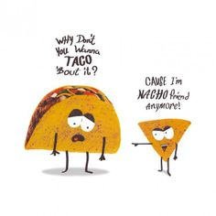

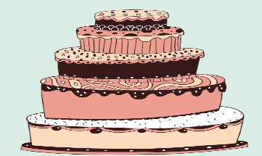
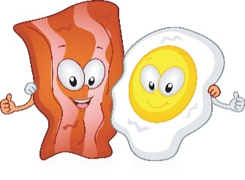
Knock Knock!
Who's there?
Bacon…
Bacon who?
Bacon a cake for your birthday!
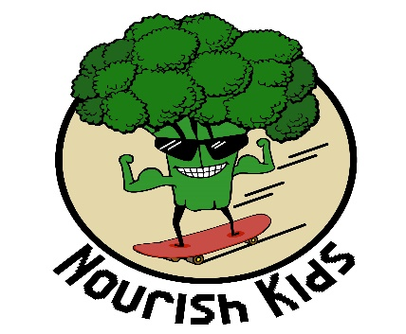
SUDOKU

How to play:
Each row across must contain the numbers 1 through 9
Each column (up and down) must contain the numbers 1 through 9
Each square box must contain the numbers 1 through 9
GOOD LUCK!
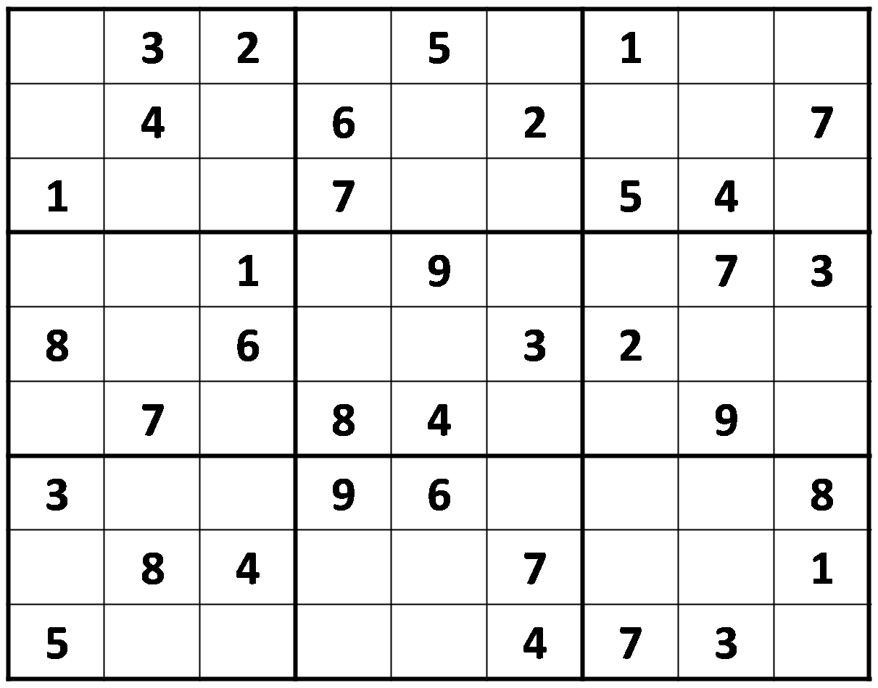
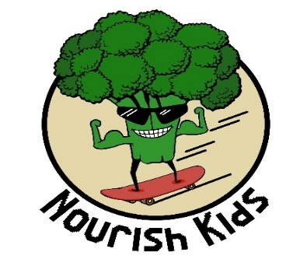

WORD SEARCH

D T A S A Y A T M D M M C L Z
B O U B R U A A P D T M L E I
D O Q J U E G M M N D N N A I
C Q F X V N P J S O J Z L Y L
S T E Y E N I P S A L M O N O
Z T N S C U T O E E F V N R C
W U I X L V Z F B P S J Y H C
C U C R E W O L F I L U A C O
M A W C E R C B S A Z R C X R
I T L C H H T D P S Z V A T B
K I I C I I A J R L N R J K S
T R G C I I N N O Q U I N O A
S I K T R U O I U B A N A N A
G E E Y D R M G T K C J N Q J
N X F Z I L N Z S B A O V X O

BANANA PEPPERS DAIRY
BROCCOLI QUINOA IRON
CALCIUM RICE ZUCCINI
SALMON YAMS CAULIFLOWER
CHICKEN SPROUTS MAGNESIUM

Help carrot find his way to the middle of the maze

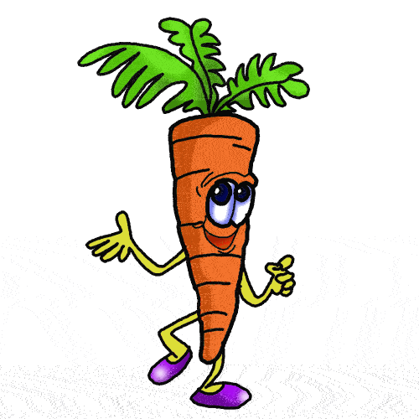
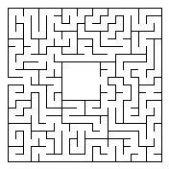

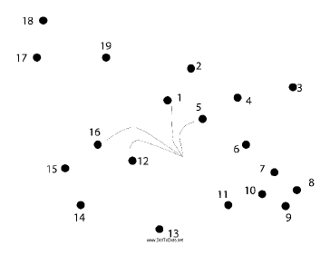

Connect the dots to see what is here!

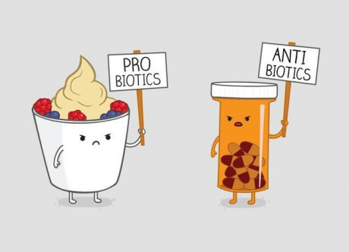

Quotes and Facts

- Eat plants, not food that is made in a plant!
- Don’t count your calories, make your calories count!
- Experience a variety of food and take the time to eat and savour every bite.
- Some diseases begin in the gut! Make sure you digest your food well…chewing your food well aids with digestion.
- We are what we eat, and we are what we absorb!
- Fibre makes you feel full faster and helps the body digest food.
- Snack on whole pieces of fruit or vegetables.
- Buy 100% whole grain bread. Sourdough and sprouted breads are great choices as they are easier to digest.
- Fried foods are unhealthy – make your own version at home!
- Go back to nature. Eat more whole foods and less processed and conveniently packaged foods.

For more information on the Nourish Kids Program or to book a session, please contact Kathy Nowak kathy@vitalflora.ca www.vitalflora.ca

Disclaimer
Everything in this activity handout is nutritional in nature and should not be construed as medical advice. Always speak to your Doctor or Naturopath before beginning a new program or going off medication

